

Name: Tan Khoon Eam

Login ID: tankhoon@oasis-portal.com

Course title: Essentials of marketing and customer relationships

Subject Code: BHM02

Submitted date: 17/7/2017

**Table of Contents**

|  |  |  |
| --- | --- | --- |
| **No** | **Details** | **Page** |
| 1 | Executive Summary | 2 |
| 2 | Introduction | 3 |
| 3 | Assignment Question |  |
|  | Part 1 | 4 |
|  | Part 2 | 5 - 6 |
|  | Part 3 | 7 - 9 |
|  | Part 4 | 10 |
| 4 | Conclusion | 11 |
| 5 | References | 12 |
| 6 | Appendix | 13 |

**Executive Summary**

In this module, I had learnt about how the marketing planning in hospitality and the importance of hospitality marketing about how to do pricing, promotion, offer etc. Besides that, I also learnt about the differences between marketing and customer service, the ethics of marketing and customer service. Furthermore, I also learnt about the concept of marketing strategies in hospitality industry and the key of success in a business through marketing plan. In addition, I learnt about the customer service skills, role, responsibility and how it functions in Hospitality Management. Lastly, I learnt about importance of customer service that contribute to the hospitality industry.

**Introduction**

The important of marketing and customer relationship is about how marketing plan and work toward the packaging of products, the pricing of products by giving special promotion and discount that able to compete with other competitor to attract more customers. Social media and new ways of people interacting with each other has a profound impact on marketing landscape nowadays, marketer will do advertising through social media such as Facebook, Instagram, E-news etc. to expose goods, products and services to attract the intention of customers. Besides that, behavior of current society that keep on demanding for a better quality of life that influent the market must keep on upgrading wider range of goods, only that can pick up the trend, marketer is the one who need to do marketing and emphasize it to public. Besides that, current customers behavior are different compares with previous time, now a day sale after services is very important, by provide a good customer service is the main key point that build up a trust and confident for consumer then only that can make customer/consumer keep on repeating of consuming goods and services that provided. Eventually, through out a successful marketing and after sales services will build up a closer relationship, these will be the key of success for a company through marketing and customer services.

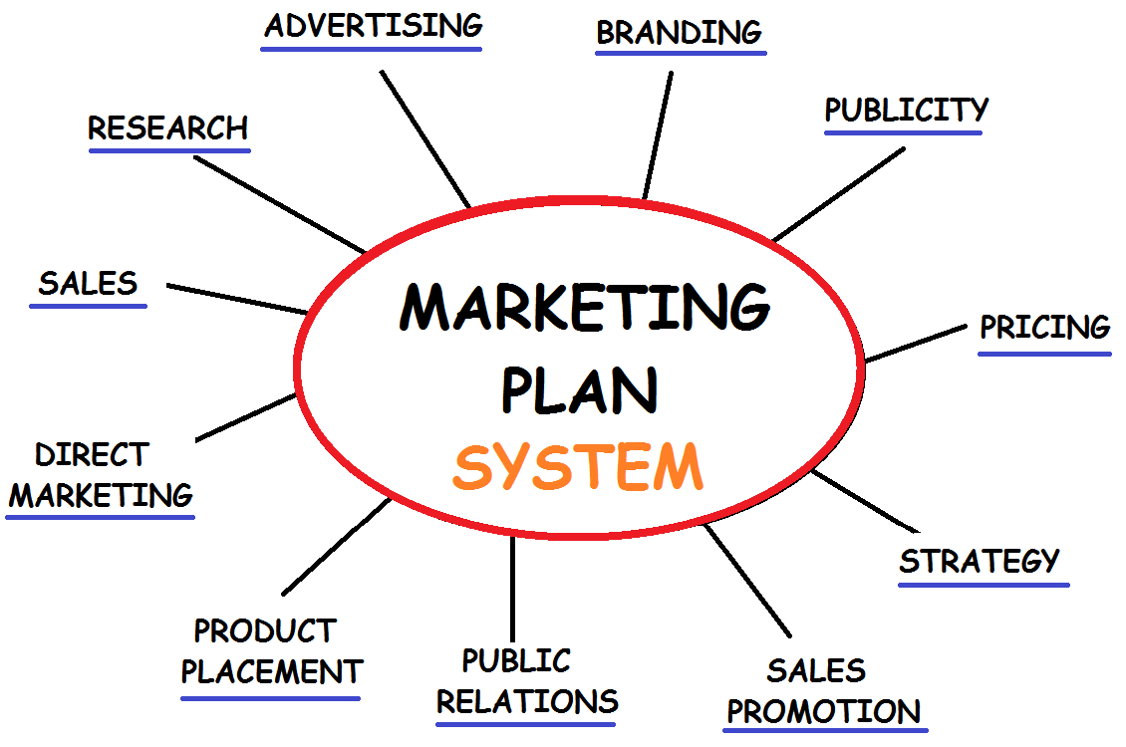

Figure 1

**Assignment Questions**

**Question 1**

Briefly explain about Marketing in Hospitality and The importance of Hospitality Marketing.

Marketing is a concept that analyze and understand what customer needs, from here will plan, design goods/products and services to attract customer. Based on customer needs and satisfaction them. Marketing is the most important part in a business, without marketing none of customer would know about the products and services that provide, because marketing is a process/channel that emphasize and promote products or services to potentials customers. Without a proper marketing very hard for a business to sustain and success, eventually sales may affect and companies may collapse. Apart from that, Marketing is a main tool to function as advertising, selling and delivering products information to people get the attention of target audiences by using slogans, packaging design, celebrity endorsements and general media exposure. **(Investopedia, LLC)**

The important of hospitality marketing **(Chron)**

* Getting Word Out – This will let the world know about company products and services that provided. In each and every business if without letting people know what products or service that provide how does a potential customer aware it. This is the reasons of using marketing to let potential customers aware what are the products and services offerings, to let potential customers discover it, also promoting brand to existing loyalty clients.
* Higher Sales – When a company starts to advertise about products or services, is a chance for new customers get know about it and make purchases. Once the new customers amazed by the services or the products they discovered, they will start to share it to with their family members and friends. Sales will slowly increase as the word spreads. If a company without doing any marketing strategies this would not be happened and without any sales company will not be succeed.
* Company Reputation – The company reputation is one of the factor that determine business successful or not. Having good marketing will help builds brand name recognition. When a company reaches the high expectations of the public, then the company will stable. When reputation grows, the business expands and sales will increase. To build a good reputation of company, company need to actively participation in community programs which communicate with both internally and externally about offer quality products or services, to support marketing efforts.
* Healthy Competition – Marketing makes the marketplace for healthy competition. When Marketing present the pricing of products and services to the market, it not only reaches the intended consumers, but also reaches other companies competitor those are selling in the same industry. As opposed to companies that have a monopoly on products and services that can charge almost any price, marketing helps keep pricing competitive for a business to try to win over consumers before its competition does. Without competition, monopoly companies would continue to sell their products, while other small companies or new companies difficult to stand a chance of ever becoming successful. So, marketing enables those small businesses and new businesses to be successful enter and grow in the marketplace.

**Question 2**

Explain the different between Marketing VS. Customer Service.

Explain the Ethics of Marketing and Customer Service.

The different between marketing and customer service. **(Chron)**

|  |  |
| --- | --- |
| Marketing | Customer Service |
| Marketing are activities of a company that promote and get the attention of target audiences by advertising, promotion, packaging design etc. of products and services through this way make business.  Marketing also through some social media advertising, to deliver products information. Some may get know about some products and services by hear the words mouth to mouth to get know about it and then from here to try the products and services.  Customers will base on the attraction of the products packaging, advertisement information, from here will using the products, after that will determine the satisfaction of the product itself, if satisfy then will continue for next purchase, if not then will look for other brands.  Marketing normally relies more on business and products but not relies on building relation. Relation only building by product itself such as branding, recognition that attract people wish to have one of it.  Marketing progress is something that you can be see and perform in physical that you can try and feel the products itself. | Customer service is the act of taking care of customers, by providing and delivering professional, high quality of service to customers. Such as talk politely to customer regarding the products feature, promptness, personalization etc. by this way to win the customer heart and trust to make business.  Customer service is personal encounter by direct email to a customer, direct telephone making appointment with customer to meet in person from here to deliver the massage and information to customer.  Client will base on the service that provided to them, from the way that explain to them and serve them from here to win the client heart, if the customer enjoys the way of service then they will continue the business deal. Customer service is based on loyalty services that provided to win the trust from the client.  Customer service base on the trust and reliabilities with client, once the first service provided a good impression then slowly time by time will gain the trust of the client without knowing will build up a relationship that can continue businesses.  Customer service does not perform in physical and it only relies on the services provided and the trust, believe between each other, it also need to take time to build and maintains. |

The Ethics of Marketing and Customer Service.

Ethics of marketing is a marketing strategy and the philosophy of guidelines for all marketer that which is the right way of marketing that what can be do and should not be do. Marketing should promote the service or products with honesty, fairness, and responsibility in all advertising. Ethics is a notoriously difficult subject because everyone has subjective judgments about what is “right” and what is “wrong.” For this reason, ethical marketing is not a hard and fast list of rules, but a general set of guidelines to assist companies as they evaluate new marketing strategies. There are few principles of ethical marketing which is all marketing communications must share the common standard of truth about the product feature and function. Advertising must be clearly distinguished from news and entertainment content and should be transparent about the products sources, pricing so that not misleading the consumers. Consumers must be also treated fairly based on the nature of the product regarding the ingredients that not bringing any affect after used. The most important things are marketers must always comply with the regulations and standards established by governmental and professional organizations. ([Marketing-Schools.org](http://www.marketing-schools.org/index.html))

Ethics of customer service in every business refers to standards of right behavior that established by the owner of the business and members of the organization that how they are dealing with each other between customers or vendors. One of the benefits of maintaining high ethical standards will increased the customer satisfaction which can lead to repeat business from the customer and valuable word-of-mouth endorsements of your company to other potential customers from here to make more businesses. There are few ethics of customer service, selecting the right product for customers. Good ethics salesperson will help customers find the most suitable product for their needs, but not only focus with the greatest revenue or highest profit margin products. Once, the customers feel that the products are what their specific needs, this will turn into higher customer satisfaction. Reliable source of information, ethical person will not make exaggerated claims about the benefits of products or services that make untrue statements. If customers find out that they had been cheated once, they will never come back again, the person that provide reliable information will make customers likely to come back for their future need, the quality of information provided is part of a satisfying purchase experience for customers. A good ethical customer service person will not oversell the customer things that not needed by the customer also, they will keep their promises that they had make to customers. **(azcentral)**

**Question 3**

Describe about Marketing strategies and how you can apply your studies in Hospitality Management.

The marketing strategies that apply for current culture are SWOT Analysis, PESTEL Analysis and 7’P Marketing strategies.

SWOT Analysis is an acronym for strengths, weaknesses, opportunities, and threats. The assessment of comparative strength and weakness of a company in relation to its competitors and internal factors of the company. Opportunities and threats, which a company may have to face in the future or external factors.

Strengths - The power and excellence with the resources, skills and advantages that what in you company have but other competitors may lack of. Example if you open travel agency, in your company you hire many workers from all over different country, if a customer wanted to go a country that maybe one of your staff live there, then your company can provide a lot of information regarding that place, that maybe other competitors do not have any information regarding that place.

Weakness – The incapability, limitation and deficiency in resources that what in your company short off or lack off, compare with other competitor, maybe other competitor that can provide a lot of different discount and promotion but due to limited of resources in your company that not able or effort to do so.

Opportunities – Environmental opportunity is an alternative area for company that would enjoy a competitive advantage. The strategy location of the business area or maybe some special festival seasons that due to external factor bringing benefit for company.

Threats – The challenge elements in the environment that could cause trouble for the business or project that unavoidable that will affect company. Example, government suddenly increase the price or maybe around your business area developing that affect your business progress.

PESTEL Analysis it helps to spot the business opportunities and provide advances warning of significant threats and it reveals the direction of change within the business environment. Through PESTLE analysis will help to avoid starting project or business that are likely to fail, for reasons beyond control. It can help companies break free of unconscious assumptions when companies enter a new business environment.

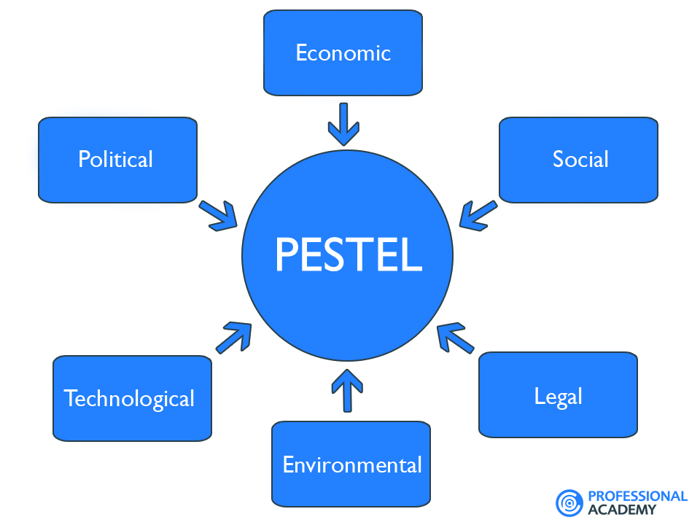

Political factor - There are all about what government implement in the regulations or deregulations that may affect in your business, such as government policy, foreign trade policy, tax policy, environmental law, trade restrictions, special local, state, federal laws etc.

Economic factor - Economic factors have a significant impact on how an organization does business and how profitable they are which depend on the economic growth, interest rates, exchange rates, inflation, disposable income of consumers and businesses etc.

Social factor - Are the areas that involve the shared belief and attitudes of the population. These factors include population growth, age distribution, health consciousness, career attitudes and so on. Also base on the interest, lifestyle of the people around.

Technology factor - Technology will impact the way of market products. Technological factors affect marketing and the management. To overcome this situation marketer, need to use the new ways of producing goods, distributing goods and services, communicating with target markets by the latest social technology.

Environment Factor - Due to the increasing scarcity of raw materials, environment pollution, carbon footprint targets set by governments. This will be the challenge for marketers facing this factor. More and more consumers are demanding that the products they buy are sourced ethically, and if possible from a sustainable source. Beside there are some businesses need face the challenge of weather or climate change.

Legal factor - Is regarding all the products equal opportunities, advertising standards, consumer rights and laws, product labelling and product safety. It is about a policy that all companies need to know what is right and what is not legal. **(Professional academy)**

7P in marketing it is about putting the right product, in the right place, at the right time, and at the right price and will turn out the result.

Product - A product is an item that produced to satisfy the needs of a certain group of people. The product can be intangible or tangible as it can be in the form of services or goods. First must ensure that the product that is in demand for market, then need to ensure the quality of the product, the packaging of the image of product, period of warranty and assurance, following by the variance or types and the stock availability from time to time.

Price - Price of the products or services are amount that a customer need to pays for enjoy it. In the other words can say as the amount of the consumer must pay to exchange the offering. Price is a very important component of a marketing plan as it determines the profit that making for a company. Adjusting the price of the product will turn up with a big impact which affecting the sales and demand of the product. To increase the sale, marketer will provide some discount on price and for the consumer convenience to make payment they will provide different types of payment method such as credit card, online transfer to attract more consumers.

Place - Products placement or distribution is a very important part of marketing, if the products place in right position then it will attract a lot of potential buyers. Current culture the product or service that provide placement channel can be very wide of range it can be done through online, door to door service etc. which mean you can do business anywhere as long you have targeting market.

Promotion - Promotion also very important component of marketing as it can boost brand recognition and sales. Promotion will happen once company launching new product or having sales promotion that wanted to share the information and activities for customers. Promotion can be done through advertising by social media, banner, brochure etc. to attract the attention of the customers.

People - Everyone that directly related or involve into the business such as company employee, supplier, customers etc. to function the business. Example employees are important in marketing because they are the ones who deliver the service. It is important to hire and train the right people to deliver superior service to the clients, whether they run a support desk, customer service, copywriters etc.

Process - The procedure that the services is deliver and to ensure a working business that is running effectively. Example understanding what are the target marketing and then deliver the message through IT support, design the product feature that suitable for current trend do research and development so company can progress.

Physical Evidence - In every industry, there should be have their own physical evidence which mean a place that the service was delivered. Additionally, physical evidence also come across with the brand presence itself regarding how long the business establishment. For example, when you think of “fast food”, you think of McDonalds, when you think about sport you will think about Nike. This is exactly what their presence is in the marketplace, as they are generally market leaders and have established a physical evidence as well as psychological evidence in their marketing. **(Professional academy)**

**Question 4**

Explain in detail on Customer Service Skills and Characteristics.

Explain the Important of Hospitality Customer Service

A good customer service skill and characteristics are very important in services line, patience is one of the important skill in customer service line, Patience is not innately gifted at birth, it is something that consciously do. The more you practice, the more patient you will become. When customers get angry and frustration, when customers not understand, no matter how many times explain it to them. All of this will happen each scenario will test the level patience. No matter what happen must think about you are the face of the company. You cannot allow a customer negativity to influence the way you treat them. Clear communication skill is a must in customer service skills communication, when talk only talk about the point that customers want to know but not all the excuses. Avoid unnecessary sentences and filler words so that words speak out can be clearly hear by the customer to avoid misunderstanding. Knowledge of the product, a good customer service representative must be able to handle most of the product question, regarding the product information and able to answer customers when customers questioning. Besides that, product knowledge is important because it will give the customer confidence in the products. Time management skill, no one appreciates those that waste time. This is a skill that need for every job, but in customer service those who waste time keep customers waiting will consider as not a good service if you do not know how to give a solution to a problem, the things that you can do which look for support from other member or manager to solve it rather than let customer keep waiting. Willingness to learn, this is probably the most general skill, but it's still necessary. There are many ways to develop customer service skills such as company training, attending courses etc. but, one of the most effective ways to learn and improve skills is to measure performance and slowly develop all the skills and characteristic such as flexibility, creativity, teamwork etc.

The important of hospitality customer service is the services that provide to a customer and ensure the customer satisfy what they paid for, by this way will generally a steady flow of loyal customers to keep the business stable and sustainable. A very good and memorable service experience that provide will always let customer have a good impression, current culture there are even more popular that customers like to leave a review of their experience on the feedback sites, whether their experience was a good or bad one, if there are many bad feedback reviews on the sites then this business will be effect. In any business needs to keep customers and cli9ents, but in the hospitality industry it is so important to keep guests engaged spreading positive word of mouth (WOM), which is important for business nowadays, especially when information and choices for consumers are abundant. To ensure repeat business from satisfied customers, besides delivered what was promised (meeting the quality), services provided have to exceed their expectations too, satisfied customer will always willing to share positive experience and offer referral opportunity for the business. In Hospitality, good customer service often cannot be thought due to the intangible attributes come with it, training might only cover the good/bad practices and do/don’t limitations, most of the time, customer service that exceed expectations has to be embedded into organization culture and strive to please the customer as their main service priority. Studies also show that happier customer tend to spend more or enroll for more services, which in turn, extra revenue generated from the same set of customers.**(Chron)**

**Conclusion**

Throughout the module study and coursework done, I was able to understand better how both marketing and customer relationship contributed to organization’s success and continuity in acquiring support from consumers. Marketing is a broad subject comprises branding to distribution of the product, guided by 4P (Product, Price, Place and Promotion), in recent years, scholars added additional 3Ps (People, Process and Physical Evidence) to address the complexity of marketing activities and the scope it covers. Every business needs marketing to certain extend, in hospitality, the product offered is in service form, which is intangible in nature, marketing plays a role in building a distinctive Image in consumer’s mind (branding), ensuring certain message delivered to target audience (advertising), distinguished itself with competitors with 7Ps etc. On the other hand, customer relationship also as important, as it keeps loyal customer to generate stable and repeat business, although both marketing and customer relationship goes hand in hands, there are several main differences in term of activities involved, delivery channels, intentions, executions and tangibility. Other marketing strategies being discuss in this coursework, besides 7Ps, there are also SWOT (Strength, Weakness, Opportunities, and Threats) and PESTEL (Political, Economic, Social, Technology, Environmental, and Legal). Whereas for Customer Relationship, we list out several customer service skills and personality attributes that are required for a good relationship building. Lastly, above all of the above mentioned, ethics is the most important element because none of the business can sustain without ethical practices and culture, Ethics and fair treatment to customer should be the guidance philosophy for marketing planning and customer relationship building.

**References**

1. Online - Figure 1 <https://www.google.com.sg/search?q=customer+service&rlz=1C1CHZL_enMY722MY723&source=lnms&tbm=isch&sa=X&ved=0ahUKEwjr2p6zj4_VAhXCJZQKHWRhCVEQ_AUICigB#tbm=isch&q=what+is+marketing&imgdii=dMhQq58EeoTA4M:&imgrc=k4lXUk-13XhXFM>:
2. Online - © 2017, Investopedia, LLC Marketing <http://www.investopedia.com/terms/m/marketing.asp#ixzz4mCPX4rYv>
3. Online - Chron, The Importance of Marketing for the Success of a Business, Kristie Lorette <http://smallbusiness.chron.com/importance-marketing-success-business-589.html>
4. Online - Chron, Difference Between Marketing Products & Services, Kathy Burns-Millyard

<http://smallbusiness.chron.com/difference-between-marketing-products-services-650.html>

1. Online - © 2012 [Marketing-Schools.org](http://www.marketing-schools.org/index.html) , Ethical Marketing- Explore the Strategy of Ethical Marketing <http://www.marketing-schools.org/types-of-marketing/ethical-marketing.html#link1>
2. Online - How Does Ethics Contribute to Customer Satisfaction? Brian Hill <http://yourbusiness.azcentral.com/ethics-contribute-customer-satisfaction-17572.html>
3. Online - MARKETING THEORIES – PESTEL ANALYSIS <https://www.professionalacademy.com/blogs-and-advice/marketing-theories---pestel-analysis>
4. Online - MARKETING THEORIES – THE MARKETING MIX – FROM 4 P’S TO 7 P’S <https://www.professionalacademy.com/blogs-and-advice/marketing-theories---the-marketing-mix---from-4-p-s-to-7-p-s>
5. Online - 15 Customer Service Skills that Every Employee Needs, GREGORY CIOTTI, JUNE 20, 2016

<https://www.helpscout.net/blog/customer-service-skills/>

1. Importance of Customer Service in Hospitality & Tourism, Scott Morgan <http://smallbusiness.chron.com/importance-customer-service-hospitality-tourism-81068.html>

**Appendix**

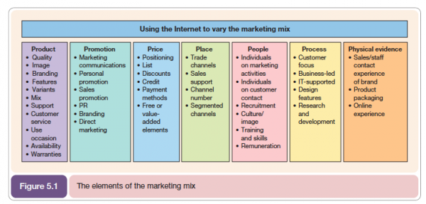

7Ps - <http://www.smartinsights.com/marketing-planning/marketing-models/how-to-use-the-7ps-marketing-mix/attachment/7psmarketing-mix-model-600x288/>

THE END